Heatherwood Middle School


2020-2021 Staff Handbook

“Becoming is better than being.” Carol Dweck

NON-DISCRIMINATION STATEMENT:

The Everett School District does not discriminate on the basis of race, color, national origin, disability or age in its programs and activities. Designated to handle inquiries about nondiscrimination policies are: Affirmative Action Officer, Carol Stolz, 3900 Broadway, Everett, WA 98201, 425-385-4106; Title IX Officer, Randi Seaberg, 3900 Broadway, Everett, WA 98201, 425-385-4104; 504 Coordinator, Becky Ballbach 425-385-4063; ADA Coordinator, Becky Clifford, 3900 Broadway, Everett, WA 98203, 425-385-5250. (Email address for each is FirstInitialLastName@everettsd.org).

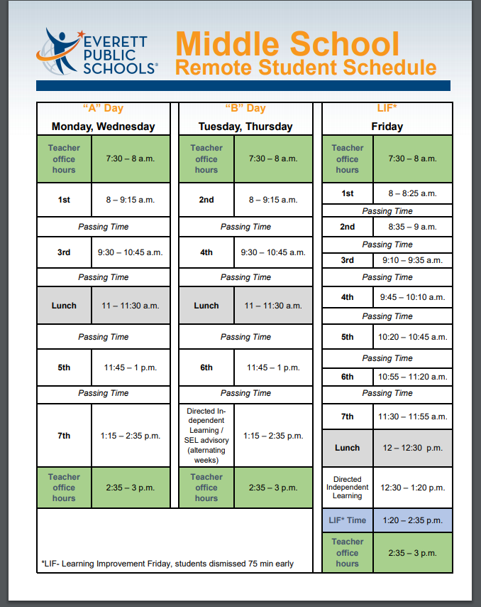

Heatherwood Bell Schedules
2020-2021

Regular Schedule
6th Grade |  | 7th Grade |  | 8th Grade
First Bell | 8:10 | First Bell | 8:10 | First Bell | 8:10
1st | 8:15-9:05 | 1st | 8:15-9:05 | 1st | 8:15-9:05
2nd | 9:09-9:56 | 2nd | 9:09-9:56 | 2nd | 9:09-9:56
3rd | 10:00-10:47 | 3rd | 10:00-10:47 | 3rd | 10:00-10:47
LUNCH | 10:51-11:23 | 4th | 10:51-11:38 | 4th | 10:51-11:38
4th | 11:27-12:14 | LUNCH | 11:42-12:14 | 5th | 11:42-12:29
5th | 12:18-1:05 | 5th | 12:18-1:05 | LUNCH | 12:33-1:05
6th | 1:09-1:56 | 6th | 1:09-1:56 | 6th | 1:09-1:56
7th | 2:00-2:50 | 7th | 2:00-2:50 | 7th | 2:00-2:50
Buses Depart | 2:57 | Buses Depart | 2:57 | Buses Depart | 2:57

Hawk Time Friday - LIF Schedule
6th Grade |  | 7th Grade |  | 8th Grade
First Bell | 8:10 | First Bell | 8:10 | First Bell | 8:10
1st | 8:15-8:48 | 1st | 8:15-8:48 | 1st | 8:15-8:48
2nd | 8:52-9:24 | 2nd | 8:52-9:24 | 2nd | 8:52-9:24
HAWK TIME | 9:28-9:59 | HAWK TIME | 9:28-9:59 | HAWK TIME | 9:28-9:59
3rd | 10:03-10:35 | 3rd | 10:03-10:35 | 3rd | 10:03-10:35
LUNCH | 10:39-11:11 | 4th | 10:39-11:11 | 4th | 10:39-11:11
4th | 11:15-11:47 | LUNCH | 11:15-11:47 | 5th | 11:15-11:47
5th | 11:51-12:23 | 5th | 11:51-12:23 | LUNCH | 11:51-12:23
6th | 12:27-12:59 | 6th | 12:27-12:59 | 6th | 12:27-12:59
7th | 1:03-1:35 | 7th | 1:03-1:35 | 7th | 1:03-1:35
Buses Depart | 1:42 | Buses Depart | 1:42 | Buses Depart | 1:42

AM Assembly Schedule
6th Grade |  | 7th Grade |  | 8th Grade
First Bell | 8:10 | First Bell | 8:10 | First Bell | 8:10
1st & Assembly | 8:15-9:56 | 1st & Assembly | 8:15-9:56 | 1st & Assembly | 8:15-9:56
2nd | 10:00-10:39 | 2nd | 10:00-10:39 | 2nd | 10:00-10:39
3rd | 10:43-11:22 | 3rd | 10:43-11:22 | 3rd | 10:43-11:22
LUNCH | 11:26-11:58 | 4th | 11:26-12:05 | 4th | 11:26-12:05
4th | 12:02-12:41 | LUNCH | 12:09-12:41 | 5th | 12:09-12:48
5th | 12:45-1:24 | 5th | 12:45-1:24 | LUNCH | 12:52-1:24
6th | 1:28-2:07 | 6th | 1:28-2:07 | 6th | 1:28-2:07
7th | 2:11-2:50 | 7th | 2:11-2:50 | 7th | 2:11-2:50
Buses Depart | 2:57 | Buses Depart | 2:57 | Buses Depart | 2:57

PM Assembly Schedule
6th Grade |  | 7th Grade |  | 8th Grade
First Bell | 8:10 | First Bell | 8:10 | First Bell | 8:10
1st | 8:15-8:57 | 1st | 8:15-8:57 | 1st | 8:15-8:57
2nd | 9:01-9:41 | 2nd | 9:01-9:41 | 2nd | 9:01-9:41
3rd | 9:45-10:25 | 3rd | 9:45-10:25 | 3rd | 9:45-10:25
LUNCH | 10:29-11:01 | 4th | 10:29-11:09 | 4th | 10:29-11:09
4th | 11:05-11:45 | LUNCH | 11:13-11:45 | 5th | 11:13-11:53
5th | 11:49-12:29 | 5th | 11:49-12:29 | LUNCH | 12:57-12:29
6th | 12:33-1:13 | 6th | 12:33-1:13 | 6th | 12:33-1:13
7th & Assembly | 1:17-2:50 | 7th & Assembly | 1:17-2:50 | 7th & Assembly | 1:17-2:50
Buses Depart | 2:57 | Buses Depart | 2:57 | Buses Depart | 2:57

2-Hour Late Start Schedule
6th Grade |  | 7th Grade |  | 8th Grade
First Bell | 10:10 | First Bell | 10:10 | First Bell | 10:10
1st | 10:15 - 10:46 | 1st | 10:15 - 10:46 | 1st | 10:15 - 10:46
2nd | 10:50 - 11:20 | 2nd | 10:50 - 11:20 | 2nd | 10:50 - 11:20
3rd | 11:24 - 11:54 | 3rd | 11:24 - 11:54 | 3rd | 11:24 - 11:54
LUNCH | 11:58 - 12:30 | 4th | 11:58 - 12:30 | 4th | 11:58 - 12:30
4th | 12:34 - 1:06 | LUNCH | 12:34 - 1:06 | 5th | 12:34 - 1:06
5th | 1:10 - 1:42 | 5th | 1:10 - 1:42 | LUNCH | 1:10 - 1:42
6th | 1:46 - 2:16 | 6th | 1:46 - 2:16 | 6th | 1:46 - 2:16
7th | 2:20 - 2:50 | 7th | 2:20 - 2:50 | 7th | 2:20 - 2:50
Buses Depart | 2:57 | Buses Depart | 2:57 | Buses Depart | 2:57

2.5 Hour Early Release Schedule
6th Grade |  | 7th Grade |  | 8th Grade
First Bell | 8:10 | First Bell | 8:10 | First Bell | 8:10
1st | 8:15-8:44 | 1st | 8:15-8:44 | 1st | 8:15-8:44
2nd | 8:48-9:14 | 2nd | 8:48-9:14 | 2nd | 8:48-9:14
3rd | 9:18-9:44 | 3rd | 9:18-9:44 | 3rd | 9:18-9:44
LUNCH | 9:48-10:20 | 4th | 9:48-10:14 | 4th | 9:48-10:14
4th | 10:24-10:50 | LUNCH | 10:18-10:50 | 5th | 10:18-10:44
5th | 10:54-11:20 | 5th | 10:54-11:20 | LUNCH | 10:48-11:20
6th | 11:24-11:50 | 6th | 11:24-11:50 | 6th | 11:24-11:50
7th | 11:54-12:20 | 7th | 11:54-12:20 | 7th | 11:54-12:20
Buses Depart | 12:27 | Buses Depart | 12:27 | Buses Depart | 12:27

ADMINISTRATIVE ORGANIZATION

In order to communicate more effectively and to better serve the needs of the building, supervision of programs will be divided between the building administrators.

Principal, Laura Wellington

• Assigns, directs, and supervises building staff.
• Evaluates and recommends retention, promotion, transfer, and termination of staff.
• Coordinates activities and assignments of school leadership teams.
• Develops the master schedule.
• Directs establishment of building budget and expenditure of building funds.
• Coordinates AVID program.
• Maintains communication with staff, students, and patrons.
• Conducts public relations program within and for the building.
- Supervises the Counseling and Guidance Program.
- Coordinates Section 504 plans.

Assistant Principal, Belinda Mountjoy

• Plans, coordinates, and implements a student behavior management program.
• Plans, coordinates, and implements a system of campus supervision.
• Establishes and maintains program of student attendance accounting.
• Assists in the supervision and evaluation of staff.
• Title IX Compliance Officer.
• Facilitates crisis/safety team-building, crisis team coordinator.
• Assumes responsibility as delegated for operation of the school in the absence of the principal.
• Directs publication of student/parent handbook.
• Oversees the athletic and ASB/activities program and the ASB budget.
• Oversees building maintenance.

Daily:

Daily Bulletin will be sent out the day before with ALL student announcements. This will be sent by Janelle.

Weekly:

Monday Morning Bulletin will include reminders, weekly events and upcoming dates. This will be sent by Laura.

Monthly:

Heatherwood Outlook Calendar: The shared Heatherwood Outlook calendar will be captured in an image file and sent to staff the last week of each month by Angie Waddle.

Heatherwood Monthly Newsletter will be uploaded to the website by Janelle.

EVALUATIONS 2020-2021

Laura Wellington | Belinda Mountjoy
Anderson, Linda | Allen, Chris
Brandt, Amanda | Barton, Carla
Brown, James | Calderon, Taylor
Burgess, Richard | Cameron, Crystal
Camp, Monica | Cooke, Bob
Coffman, Tami | Curtiss, Romes
Corbett, Brian | Decker, Cody
Cowper, Suzanne | Driscoll, Colleen
D’Ault, Doug | Herber, Sara
Fabrizio, Sharon | Hoang, Huyen
Grosvenor, Claire | Jaeger, Gretchen
Jones, Wendy | Keener, Andrea
Khim, Rosa | Lee, Erin
Lanigan, Billie | Lien, Kim
Loewen, Elona | Mills, Nicole
Lundquist, Michael | Perry, Donna
Matthews, Stacey | Pratt, Jenna
McCoy, Carter | Proudlock, Sean
Poole, Melissa | Ramirez, Anita
Rickert, Kristie | Ramon, Katy
Watson, Reija | Robison, Rebecca
Weiss, Joan | Scholz, Monte
Zinkgraf, Gregory | Seamon, April
Slater, Autumn | Sibley, David
Lerner, John | Stevenson-Bonilla, Nicole
Arpin, Myra | Thomas, Karlee
Jacques, Diane | Williams, Juli

Classified

Wellington: Waddle, Schulenburg, Crise, Jaeger, Hooper
Mountjoy: Ouderkirk, Ellis, Stauffer, Blackmer, Watkins,

2020-2021 STAFF ORGANIZATION: Office & Support Staff

EXT | NAME | ROOM(s) | ASSIGNMENT
6390 | WELLINGTON, LAURA | 212 | PRINCIPAL
6391 | MOUNTJOY, BELINDA | 205 | ASSISTANT PRINCIPAL
6301 | Waddle, Angie | 223 | Office Manager
6303 | Schulenburg, Emily | 226 | Attendance Secretary
6315/6325 | Crise, Christine | 206 | Records/Registration Secretary
6324 | Jaeger, Janelle | 235 | Office Secretary
6316 | Winter, Julie | 213 | 1:1 Student Device Secretary
6321 | Conference Room | 211
6317/6304 | Student Office Phones | 235
 | COUNSELORS
6310 | Slater, Autumn | 207 | 6th Grade Counselor
6313 | Lerner, John | 209 | 7th Grade Counselor
6314 | Arpin, Myra Flor | 210 | 8th Grade Counselor
6312 | Jacques, Diane | 211 | School Psychologist
6336 | Rohwer, Stephanie | 230 | School Psychologist
 | LIBRARY
6309 | Herber, Sara | Library | Librarian
6308 | Hooper, Sara | Library | Library Support
 | CAMPUS SECURITY
6416 | Kristi Blackmer | 116 | Campus Security Officer
6320 | Officer Todd Bridgman | 206 | Police Officer
 | NURSE
6429 | Langille, Krista | 228 | Nurse (Cell# 425-626-0943)
6306 | Greene, Pam | 204 | Health Room Assistant
 | SPECIALISTS
6427 | Anderson, Eileen | 327
6343 | Marks, Kelly | 223 | SLP
6351 | Holley, Chrystal | 231 | OT
 | CUSTODIANS
6397 | Curtis, Jeff | 128 | Head Custodian
6397 | Regnere, Jesse | 128 | Custodian
6397 | Desmarais, Kellie | 128 | Custodian
 | PARAEDUCATORS
6430 | Banerjee, Swati | 210 | Achieve Paraeducator
6430 | Ellis, Betty | 210 | Achieve Paraeducator
6431 | Holden, Courtney | 211 | Paraeducator
6300 | Johansen, Shelley |  | Paraeducator
6300 | Muramoto, Ed |  | Paraeducator
6425 | Ouderkirk, Erika | 205 | Achieve Paraeducator
6425 | Stauffer, Alysia | 205 | Achieve Paraeducator
6446 | Watkins, Toni | 306 | English Language Paraeducator

Roles & Responsibilities: Office and Support Staff

Main Office: Ms. Waddle - Office Manager

Bookkeeping - general fund/ASB
Fees & fines
Intradistrict mail
Teacher forms/supplies
Substitute coordination/timesheets

Registration Office: Ms. Crise – Registrar
Student registration/withdrawals
Student Records/Discipline
Master scheduling
Grading/Transcripts

Attendance/Student Services Office: Ms. Schulenburg – Attendance/Athletics
Attendance/early dismissal forms/passes
Homework request Pick-up
BECCA Tracking/Filing
Athletics, student activities information

Office Support: Ms. Jaeger – Communication/Discipline
Communications: Webmaster & Bulletin
Discipline
Library Budget
Parent Volunteers

Custodian Office: Mr. Curtis – Head Custodian
Cleaning/emergency repairs/ work orders
Building safety

Security Office: Ms. Blackmer – Campus Security Officers
Building security
Discipline support
Emergency supplies
Bus liaison
Lost and found (long-term storage)
Lockers

Admin Support Para/Success Support: Administrative Support Paraeducator
Supervision Support
Student Success Coordination
Attendance Support (Home Visits)
Student Ambassadors, Peer Mediations/Conferences
Academic Interventions
Assessment Support

ASB Advisor Ms. Ramirez & Mr. McCoy – Advisor
ASB/Leadership
Schedule of student activities/events
Student Council/Student elections

WEB Advisors Ms. Arpin/Mr. Corbett

2020-2021 STAFF ORGANIZATION: Teaching Staff

HEATHERWOOD LEADERSHIP TEAM

Purpose: Heatherwood's Leadership Team's purpose is to work collaboratively with Heatherwood administration and with feedback/input from grade level, content area and program area colleagues to make data-based decisions aimed at providing a school climate and instructional program in which all students learn and grow.

Mission: To build, support, and nurture a school culture/climate that is safe, respectful, and that honors the social/emotional well-being of students and staff.

The 2020-2021 Leadership Team:

Name | Representative
Wellington, Laura | Principal
Mountjoy, Belinda | Assistant Principal
Allen, Chris | 6th grade rep.
Lien, Kim | 7th grade rep.
Brandt, Mandy | 8th grade rep.
Pratt, Jenna | ELA rep.
Cooke, Bob | Social Studies rep.
Loewen, Elona | Math rep.
Lanigan, Billie | Science rep.
Watson, Reija | Lifetime Fitness rep.
Anderson, Linda | Electives rep.
Cameron, Crystal | Sp.ED rep.
Mills, Nicole | English Learners rep.
Lerner, John | Counselor rep.
Ellis, Betty | Classified rep.
Waddle, Angie | Office rep.

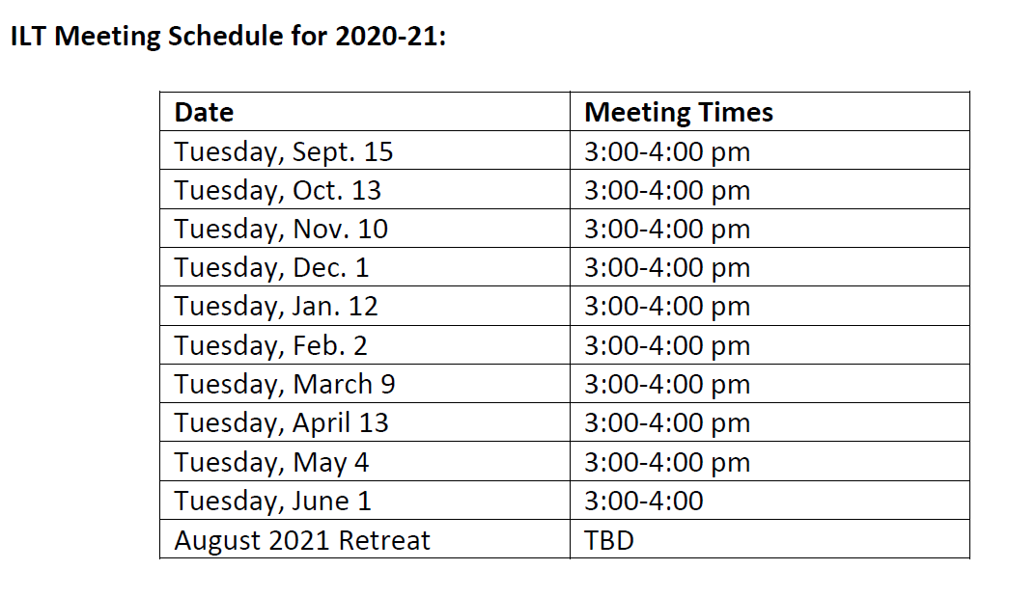

STAFF MEETINGS

Teacher Expectations
It is vital that all staff members are involved in building initiatives through staff meetings, regardless of teaching assignment. All staff members are expected to attend all meetings that relate to their assignment.

Staff Meetings
Our Extended Staff Meetings will be after school. We generally will meet in the library unless otherwise communicated. The purpose of our staff meetings are to meet as a group to discuss and review instructional and operational information as it relates to the school as a whole. All teachers are expected to attend. The dates of our staff meetings are below:
*Note: These dates are subject to change. Changes will be communicated to staff in advance.

LIF DATES September | LIF Day | February | LIF Day
11 | Employee Facilitated | 5 | Admin Facilitated
18 | Admin Facilitated | 12 | Employee Facilitated
25 | Employee Facilitated | 19 | Admin Facilitated
October | LIF Day | 26 | Employee Facilitated
2 | Admin Facilitated | March | LIF Day
9 | Employee Facilitated | 5 | Admin Facilitated
16 | No LIF- LID (All Day) | 12 | Employee Facilitated
23 | Admin Facilitated | 19 | Admin Facilitated
30 | No LIF- Conference Prep | 26 | No LIF – Full Student Day
November | LIF Day | April | LIF Day
6 | No LIF- Conferences | 2 | No LIF – Full Student Day
13 | Employee Facilitated | 9 | No LIF – Spring Break
20 | Admin Facilitated | 16 | Employee Facilitated
29 | No LIF - Thanksgiving Break | 23 | Admin Facilitated
December | LIF Day | 30 | Employee Facilitated
4 | Employee Facilitated | May | LIF Day
11 | Admin Facilitated | 7 | Admin Facilitated
18 | Employee Facilitated | 14 | Employee Facilitated
25 | No LIF - Winter Break | 21 | Admin Facilitated
January | LIF Day | 28 | Employee Facilitated
1 | No LIF - Winter Break | June | LIF Day
8 | Admin Facilitated | 4 | Admin Facilitated
15 | Employee Facilitated | 11 | No LIF – Reduced Student Day
22 | Admin Facilitated | 18 | Employee Facilitated
29 |  | Employee Facilitated

NEW: CALL BACKS EVENTS

New for the 2020-2021 school year, teachers will be allowed to choose the 3 call-back evening events to attend. All teachers must attend the fall Curriculum Night scheduled for Monday, September 30, 2019

Note: Student led conferences are not considered a Call Back. Teacher attendance for conferences is mandatory.

Evening Call Back options include:

Event | Date and Location
Curriculum Night (ALL STAFF) | September 30, 2019
HS and Beyond Night | TBD
AVID Family Night | TBD
Multi-Cultural Celebration | TBD
Technology Expo Event | TBD
Heatherwood Technology Fair | TBD
5th grade Family Night | TBD
8th grade Moving Up Assembly | TBD

Middle School Designated Nights
Every available evening during the month is reserved for a specific building level to ensure that families with students at different levels are able to attend events at their children’s respective schools. This year, the middle school designated nights are:
- 2nd & 4th Mondays
- 1st Tuesday
- 3rd Thursday
- 4th Wednesday

NON-STUDENT TEACHER WORK DAYS
These are reduced student days or non-instructional work-days for certificated staff. Individual days are planned and determined by the individual employee. District days are planned and determined by the District.

TEACHER ASSIGNMENT

Normal Work Day
All staff shall be at their assigned workstations ready to perform their assigned duties at the regular starting time of 7:30 AM. On days when the pre-announced starting time is different than 7:45 AM, staff shall be at their assigned station at that designated time.

The teacher workday is based on a 7.5-hour day, inclusive of lunch, and begins at 7:30 AM and ends at 3:15 PM. Workday is defined as being on duty at school working as a teacher supervising students whether in a classroom learning situation or a learning situation outside of the classroom. Supervision of students during the school day is the responsibility of all staff members. Normally, teachers will conduct six in-class learning situations where specific academic skills are emphasized and have one preparation period. It is the responsibility of all teachers to use their educational expertise to instruct students in the appropriate social skills throughout the school day. Teachers may leave campus during their duty-free lunch; however, they must log their absence on the sign-out/sign-in sheet in the main office for security/safety reasons. Please do not leave campus at any other time during the day unless it is arranged in advance with an administrator.

Preparation Period
One class period per day is provided to classroom teachers for preparation. The planning period is provided as a work period for preparing, organizing, developing, recording, studying, consulting, inventorying, ordering, meeting with parents, and other tasks necessary as a part of the teaching assignment.

Before and After Classes
The building will open to students at 8:00 AM and close at 3:00 PM. The building will be open to students after 2:50 PM only for supervised activities. Students dropped off at the front door will enter the Great hall at 7:55am and stay in the Great Hall until 8:00am.

Faculty Meetings
All teachers are expected to be in attendance at all staff meetings unless absent from school or absence has been previously arranged with an administrator.

Other Duties
Attendance at other functions (curriculum night, conferences, etc.), will be expected, consistent with the collective bargaining agreement.

Late Start
In the event the decision is made to begin the student day two hours late, staff will be notified via Connect Ed or the building phone tree. When activating the phone tree, please remember to call until you talk to a person. If you reach a message when calling “your person”, leave a message AND then continuing calling until you speak with a person. Staff is expected to arrive at school as close to their regular work time as possible on student late start days.

TEACHER workdays will be from 7:30 AM to 3:15 PM.

Securing a Guest Teacher Substitute: Please utilize the web-based attendance program Frontline to report an absence. The system may be accessed from the District Home Page under Staff Information. You will need to do the following:

Log in to Frontline (user ID is your Employee ID, if you forgot your password, please call the sub desk at 425-385-4111)
Create an absence – please report your absence at least 2 hours prior to your scheduled start time to allow sub system time to reach out to subs.
Enter either half day (AM – 7:45-11:30 or PM – 11:30-3:15) or a full day absence
Enter the date(s) you will be absent*
Add attachments if you have any, or e-mail them to the Office Manager
Call or e-mail the Office Manager to leave any specific instructions for the sub.
If you have questions, please call the sub desk at 425-385-4111 or Heatherwood main office at 425-385-6300

*Leave without pay requires prior HR approval, use Leave of Absence Form

GUEST TEACHER FOLDER/SUB FOLDER

A “Guest Teacher” file should be in your room for the “Guest Teacher” and include:

- Class Expectations.
- Teaching schedule.
- Supervision duties if any.
- Seating charts.
- Special need students and their conditions.
- Lesson plans.
- Emergency activity if no lesson plan can be provided.
- Particularly helpful students the sub can use for assistance.
- Emergency/evacuation procedures.
- Guest Teacher input sheet.

SHOULD YOU NEED A GUEST TEACHER WHILE AT WORK

- Notify an administrator via intercom or note with student.
- State the nature of the problem: whether it is an emergency which requires
immediate coverage for your class or whether you can carry on while an attempt is made to find a substitute.
- Write a note to the prospective substitute indicating location of lesson plan, attendance and seating chart, and any extra duties such as student supervision.
- Unless an extreme emergency exists, stay with your class until you are relieved. As soon as an administrator knows of your problem, every attempt will be made to cover your class or find a substitute.
- You are not to leave campus until released by the Principal or Assistant Principal.

Information regarding Safety & Evacuation please see the “Emergency Plan” Handbook. See Ms. Mountjoy for questions

Information regarding ASB/Athletics/Student Expectations please see the “Student Handbook”.

Addendum: PBIS Hawk Time Lesson Dates

Teacher Expectations
Once a month every first period class will have extended time for a PBIS monthly lesson. The bell schedule for the day will be adjusted using our Hawk Time bell schedule.

Second Step Lessons
The 2nd period teacher will teach a specified lesson(s) during the Hawk Time weekly lesson. The lessons are taught using our Second Step curriculum. Teachers will be trained annually on how to use the Second Step curriculum during the August Teacher LID days.

See your PBIS – Second Step Booklet for the outline of weekly lessons per grade.

